1. INTRODUCTION

1.1 Overview

Dream homes realty is a construction based

company. Dream homes, a fast growing real estate company.

The company provides a host of realty services

to clients which include Construction Services and Architectural Services. We are leading construction company committed to delivering exceptional building solutions.

Dream Homes takes care to provide reliable property options and investment opportunities to clients besides providing other specialized realty services.

Dream House Realty is one of the best Real Estate Advisory & consulting Business Organization.

1.2 Purpose

The company aims to consistently make great strides in fulfilling the dreams of a large number of esteemed customers.

It is armed with a team of talented professionals who are very knowledgeable and proficient in the real estate sector and are always ready to deliver more than what has been asked for.

For every single client, we will work as hard as we can to help them achieve their dreams

2.Problem definition& Design thinking

2.1.Empathy map

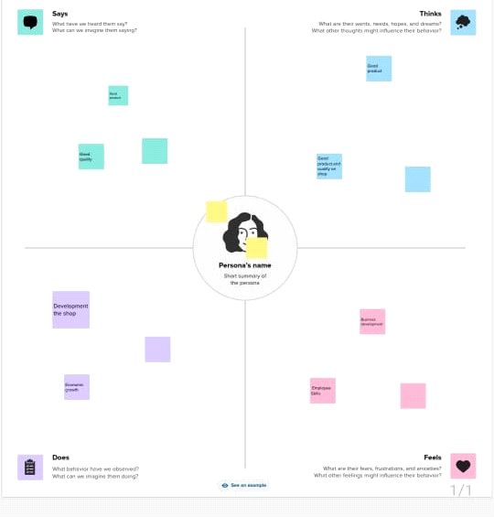

2.2. Ideation & brain stroming map

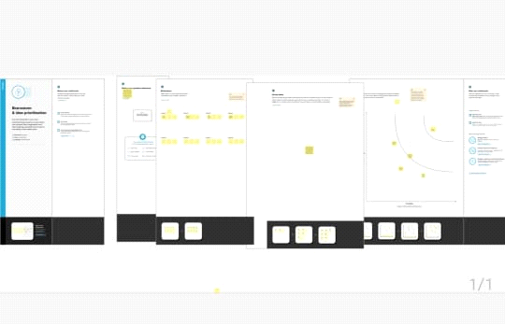

3.Result

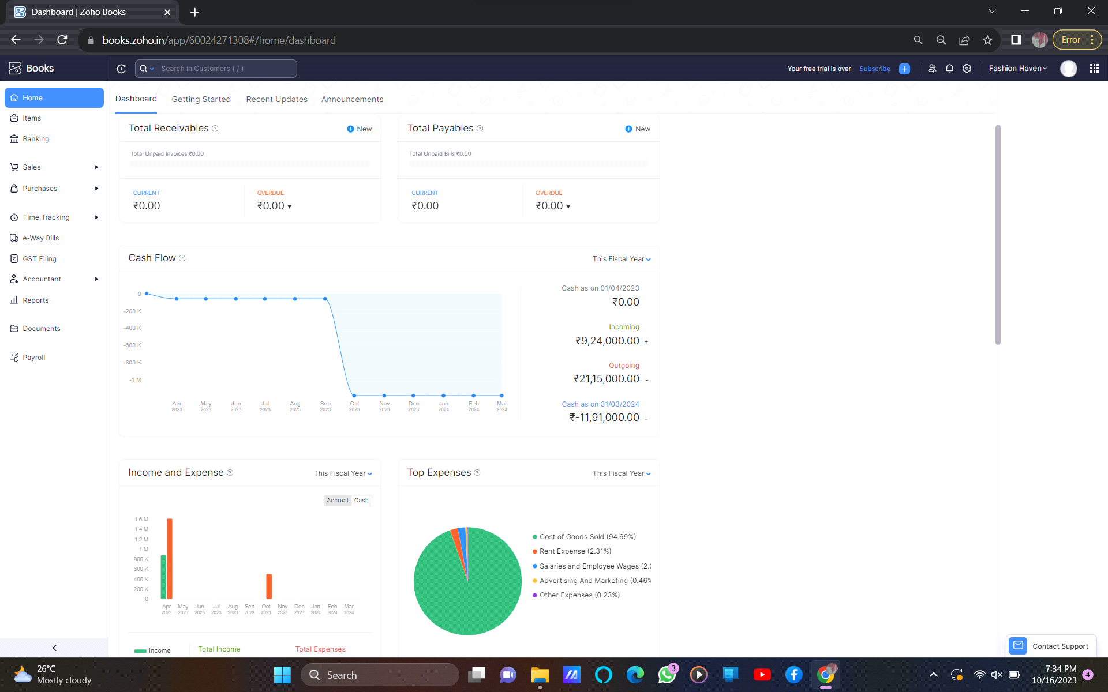

4.Vendors

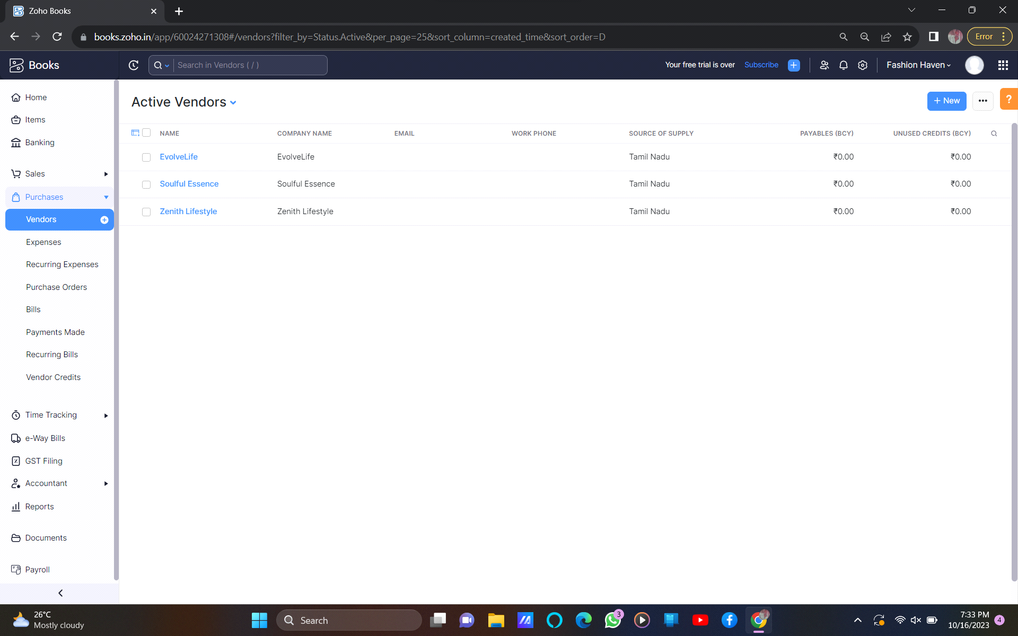

5.Customers  
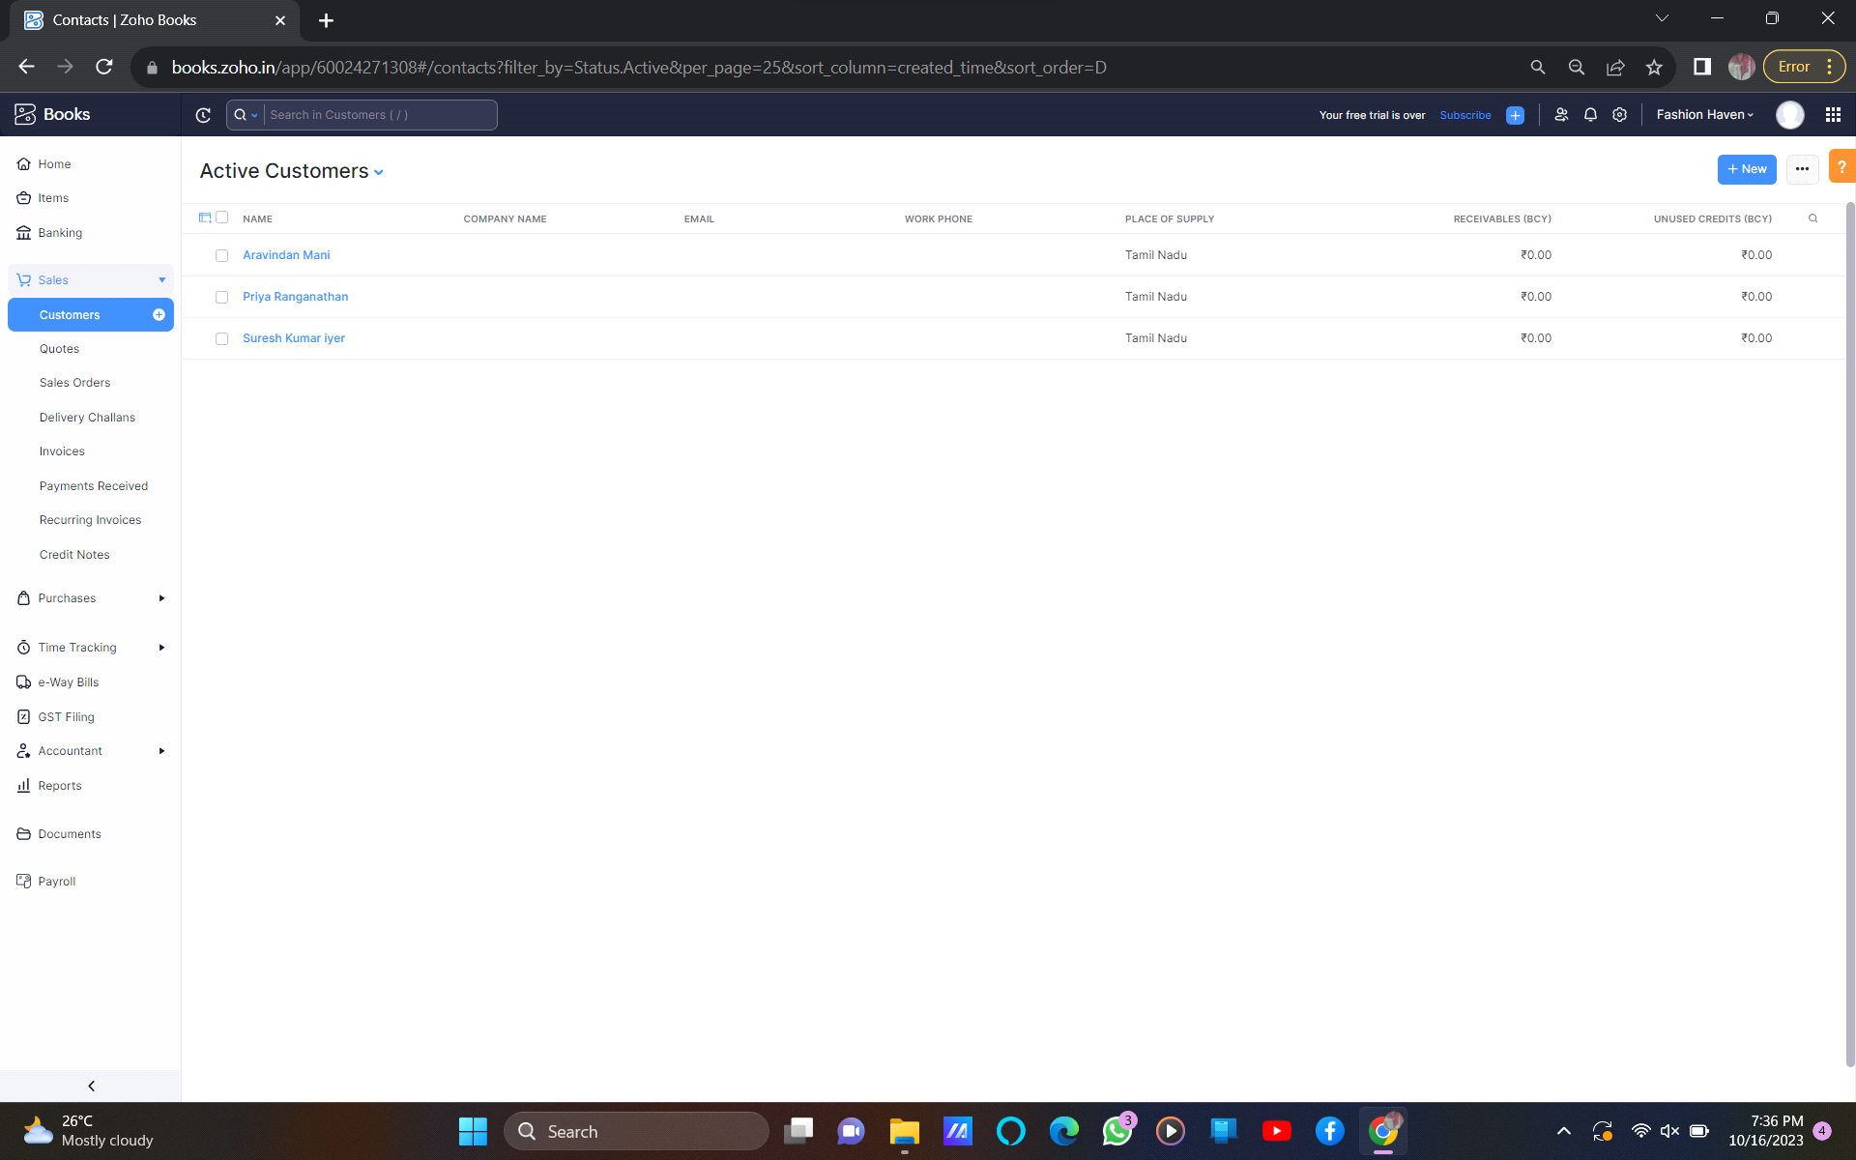

expenses

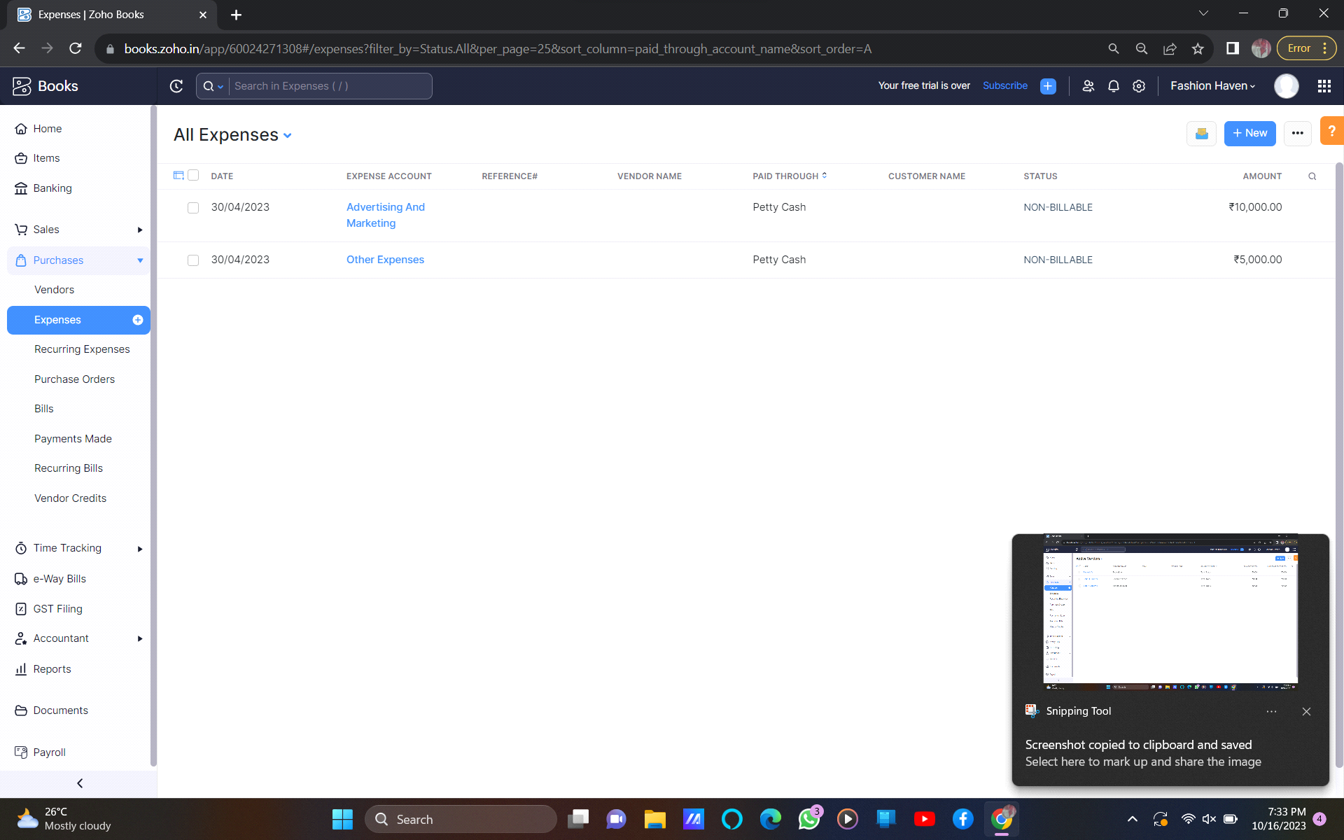

sales order

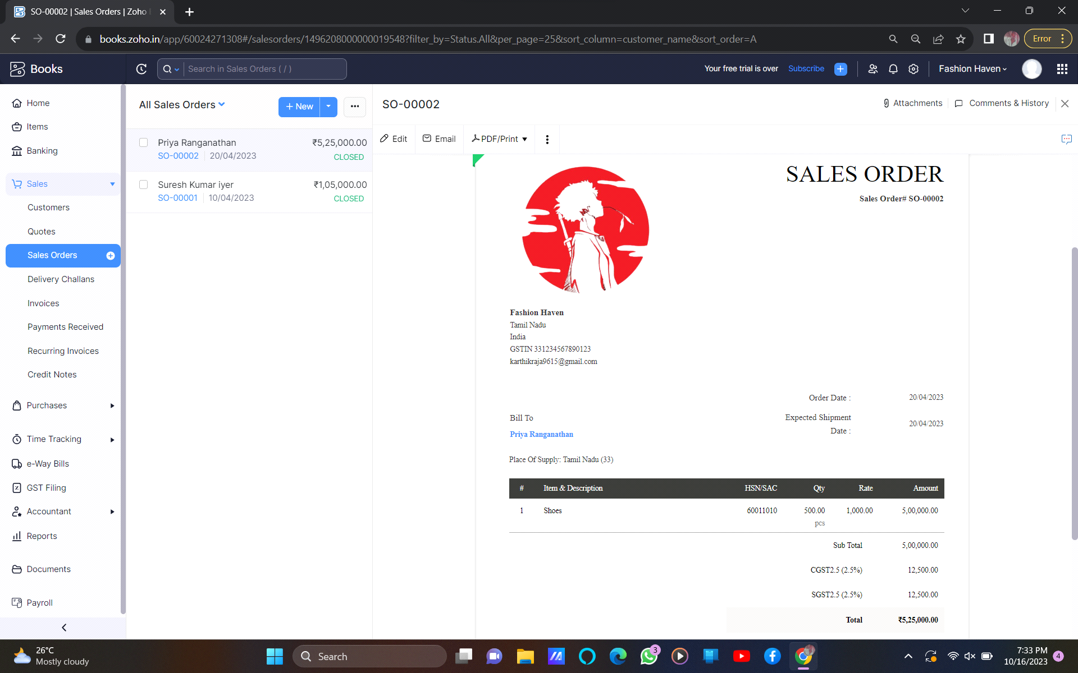

purchase order

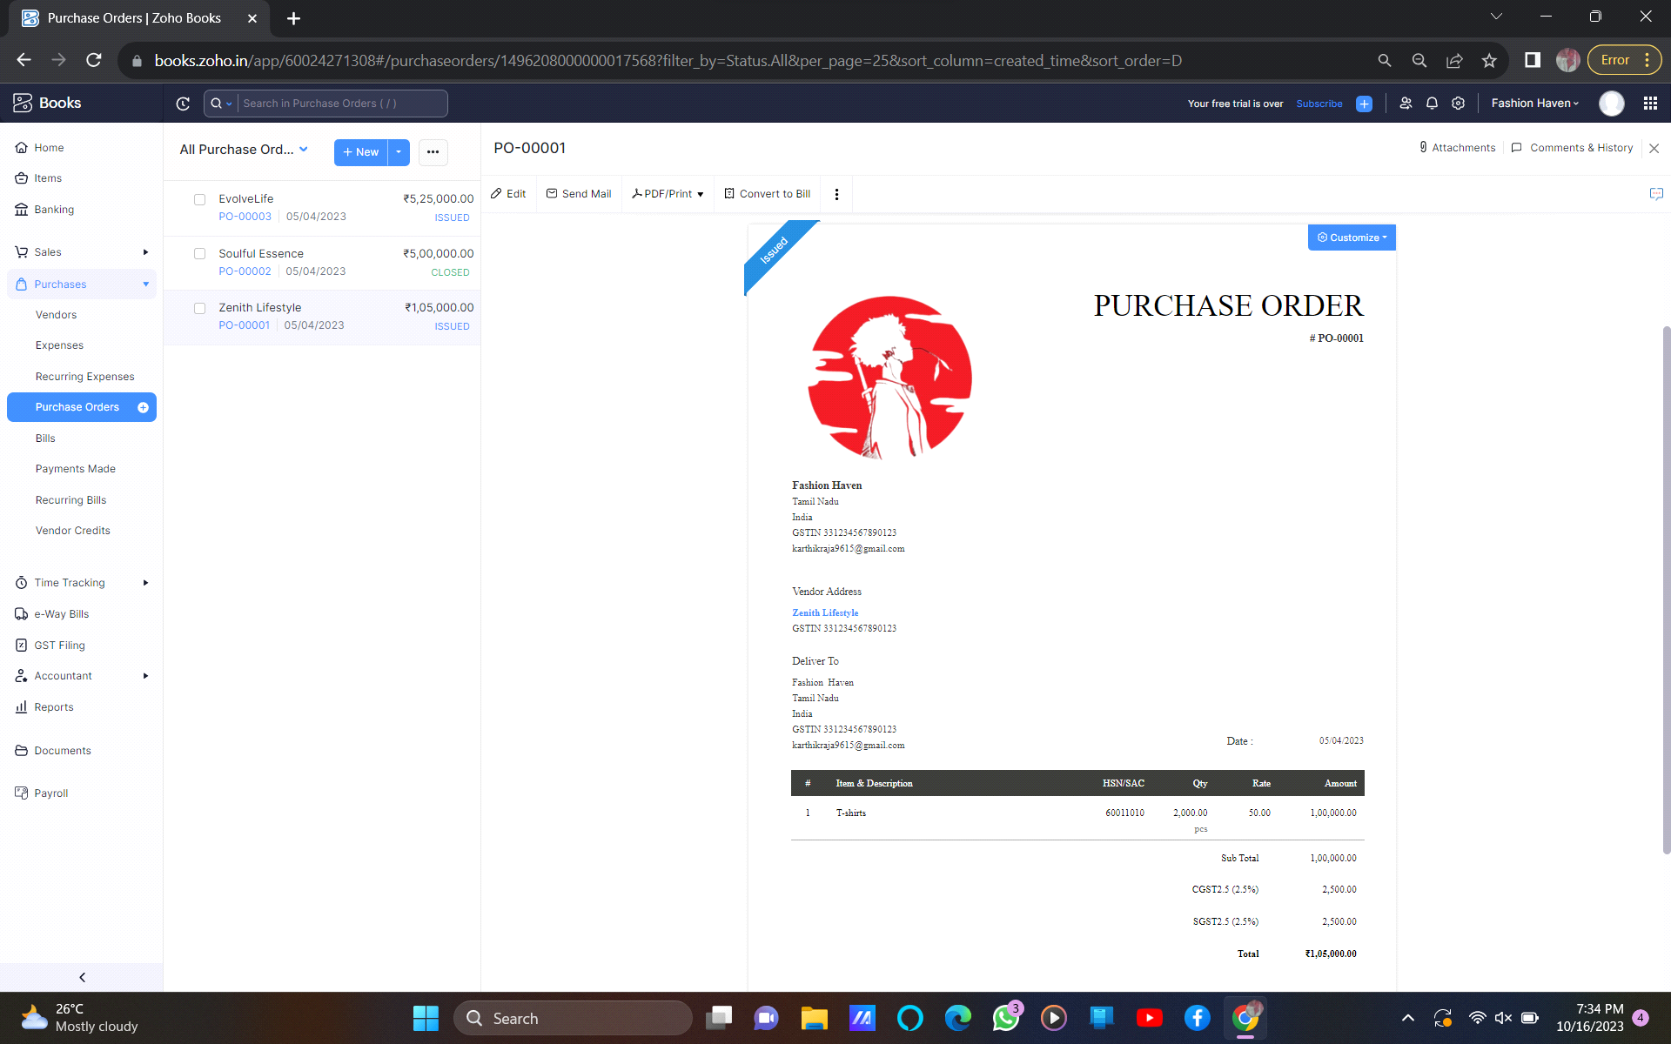

journal report

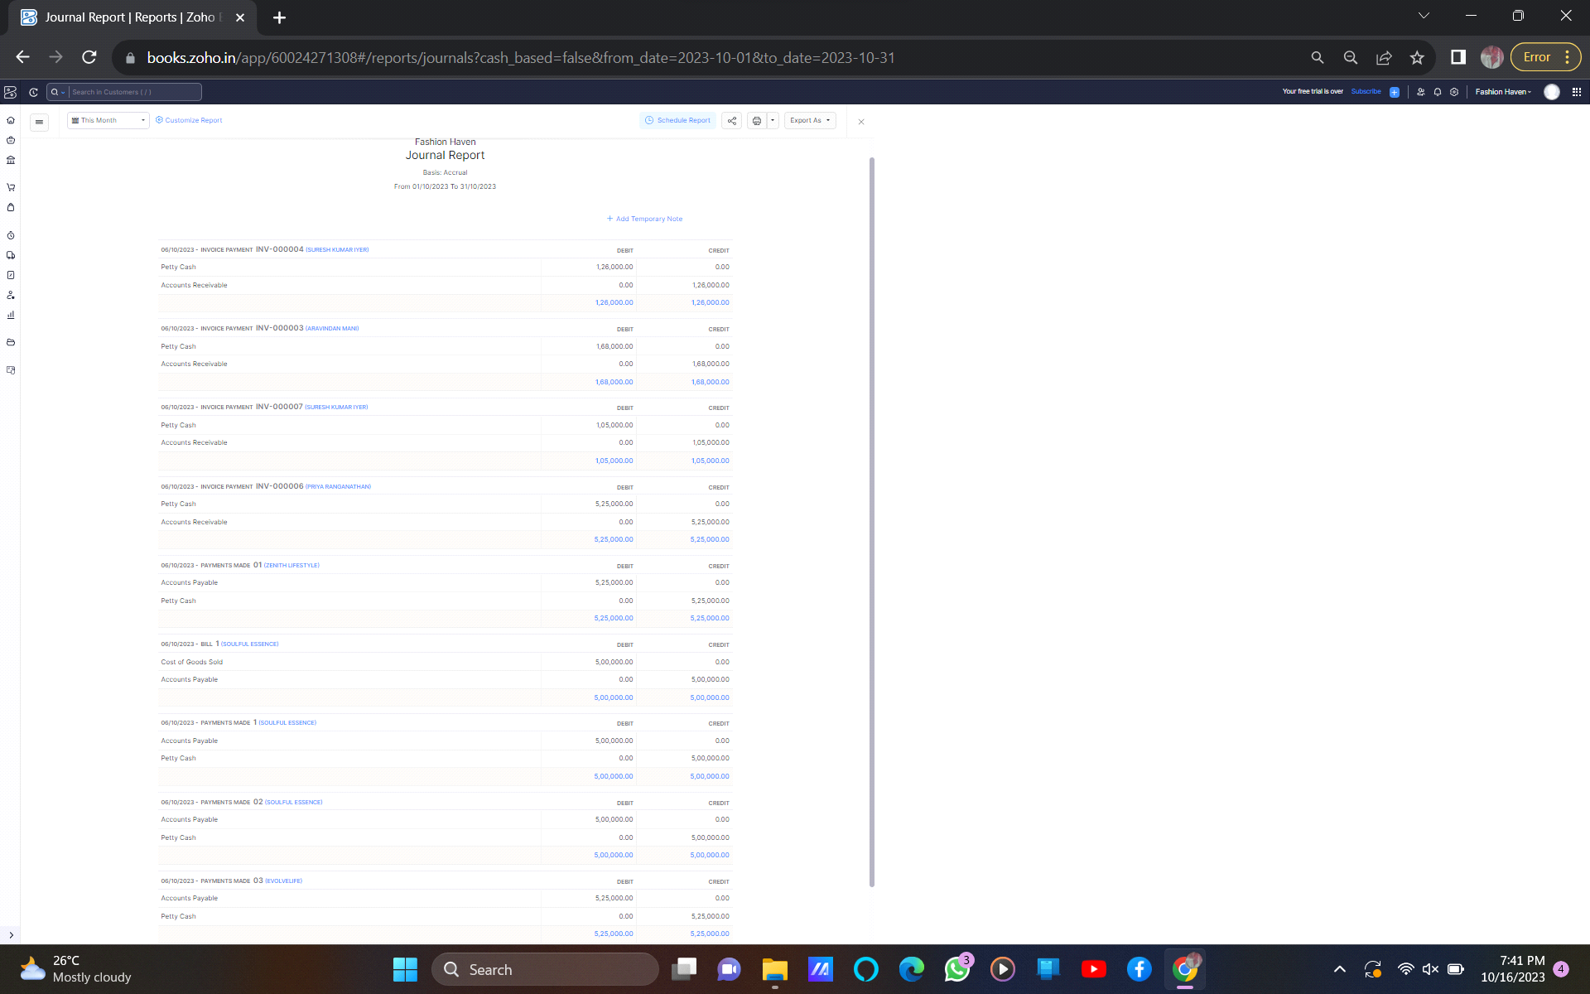

profit & loss account

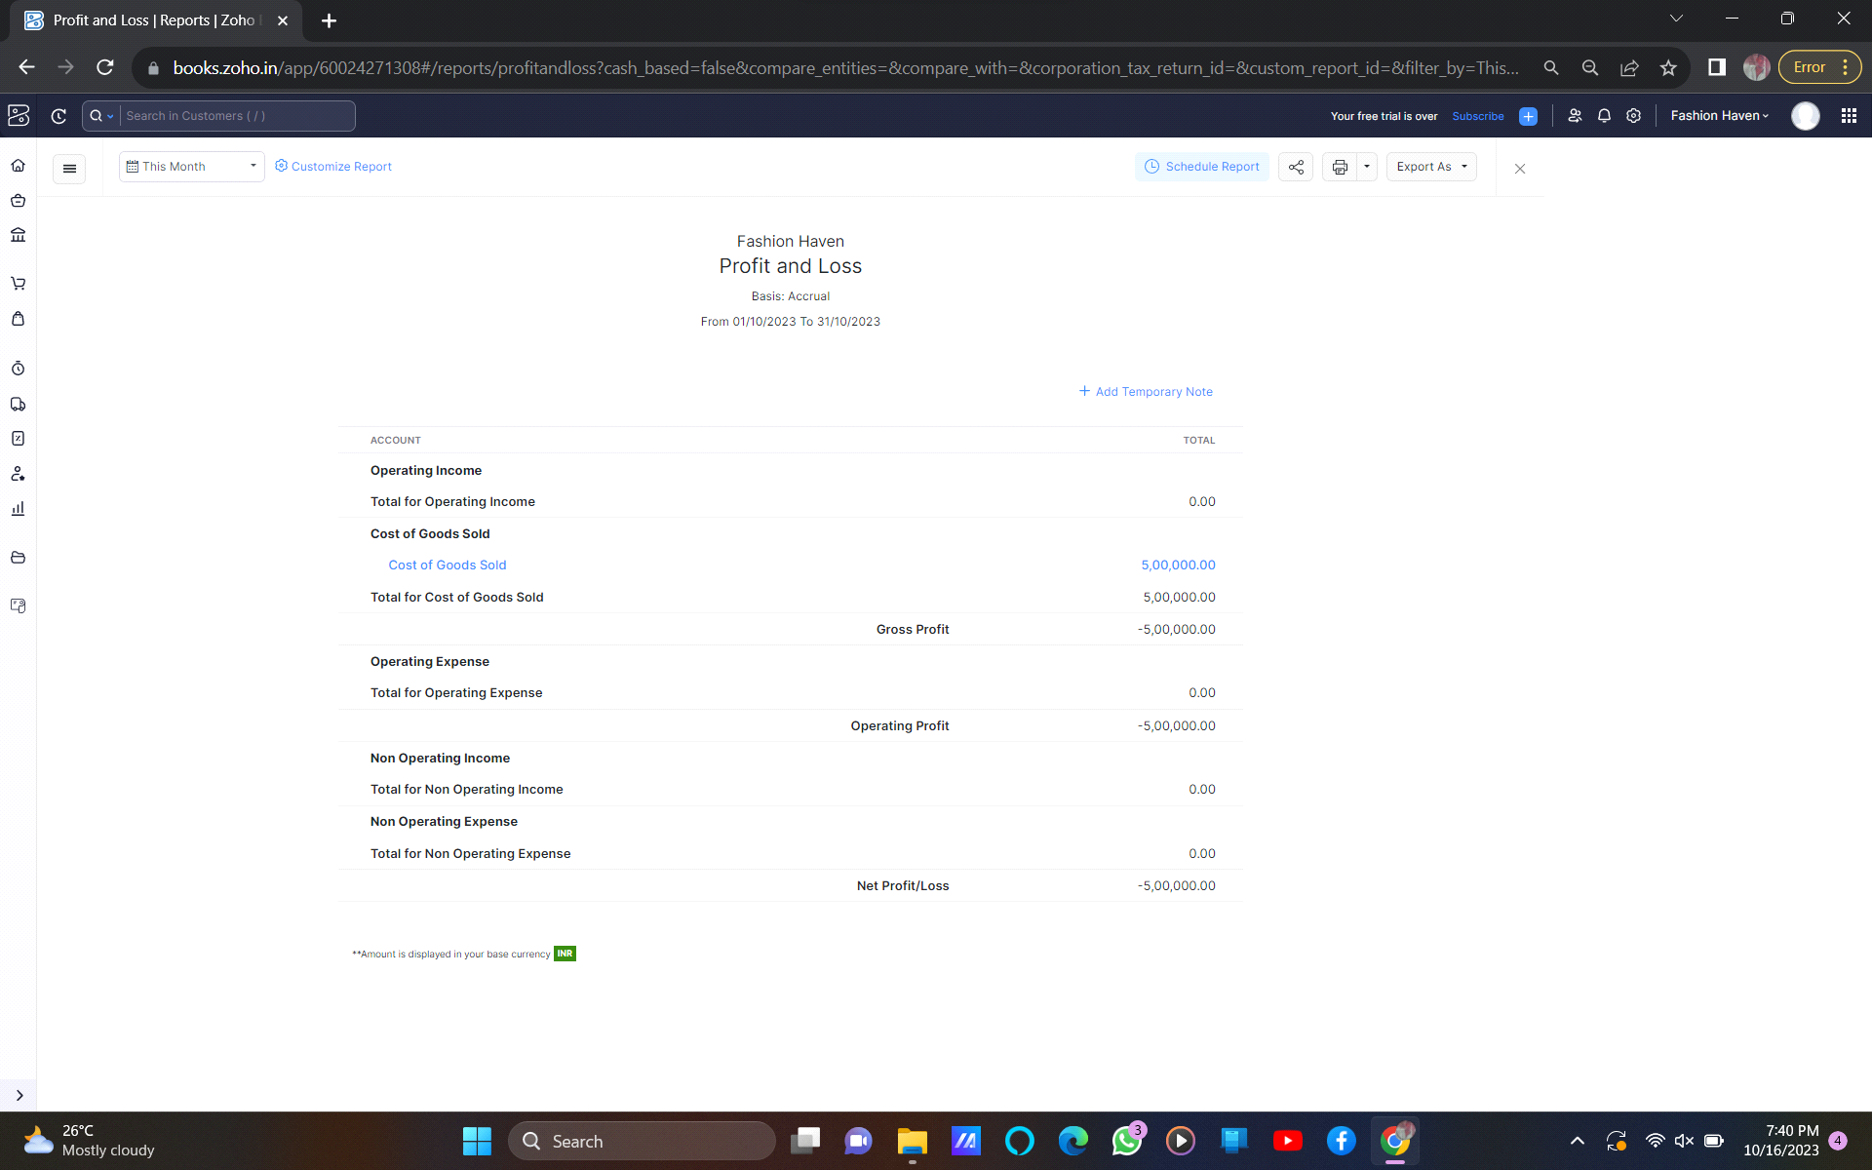

balance sheet

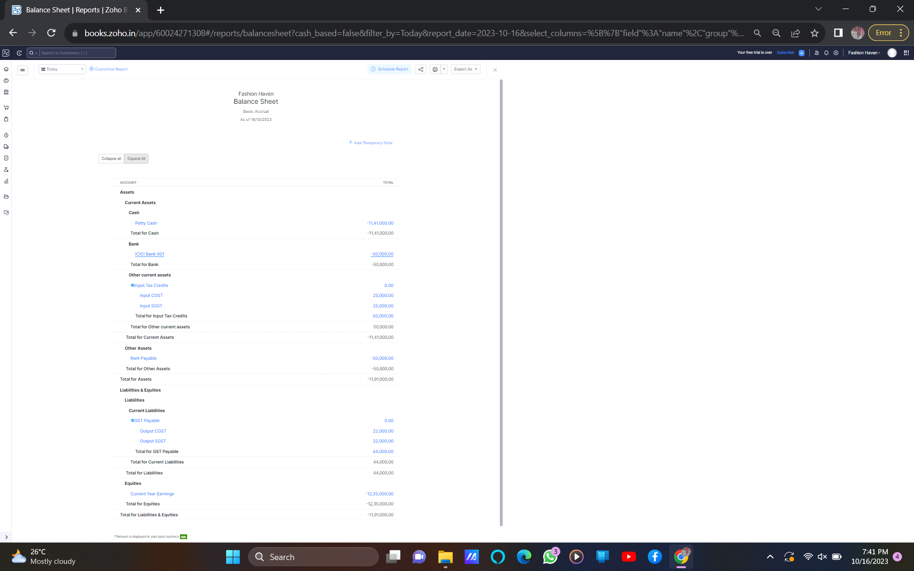

4. Advantages & disadvantages

Advantages

One of the main advantages of investing in real estate is that can be used as leverage to finance other When used as financial securities, realinvestment is that it is a good hedge against inflation.

One of the main advantages of investing in securities, real estate 18 Dream homes realty is real estate business. It’s improvable to increase its values.

Disadvantages

Real estate investments tend to have high transactional costs, especially in legal and brokerage fees. The process of acquiring a new property is also very long and tedious with lots of legal formalities. Another disadvantage of property investments is that they are not easy to liquidate.

5. Application

Zoho books is an easy-to-use, cloud based accounting software with an invoice, inventory and project management system. It offers a competitive free plan and a variety of featuresto make your processes easier and more efficient. And it is cloud based so any system we can login and use pass the entries.

6. Conclusion

It gave a better experience to me and I learned how to use it, how to record transaction etc…it you can easily to develop your projects also. You can easily way to access anything have like phone, pc, laptop.

7. Future scope

It’s become powerful accounting software. The majority of business persons will use it. I know how to handle it so, I have chance to join any company. For example, it could offer features that are specifically designed for restaurants, retail stores, or e-commerce business.